11.12: a)
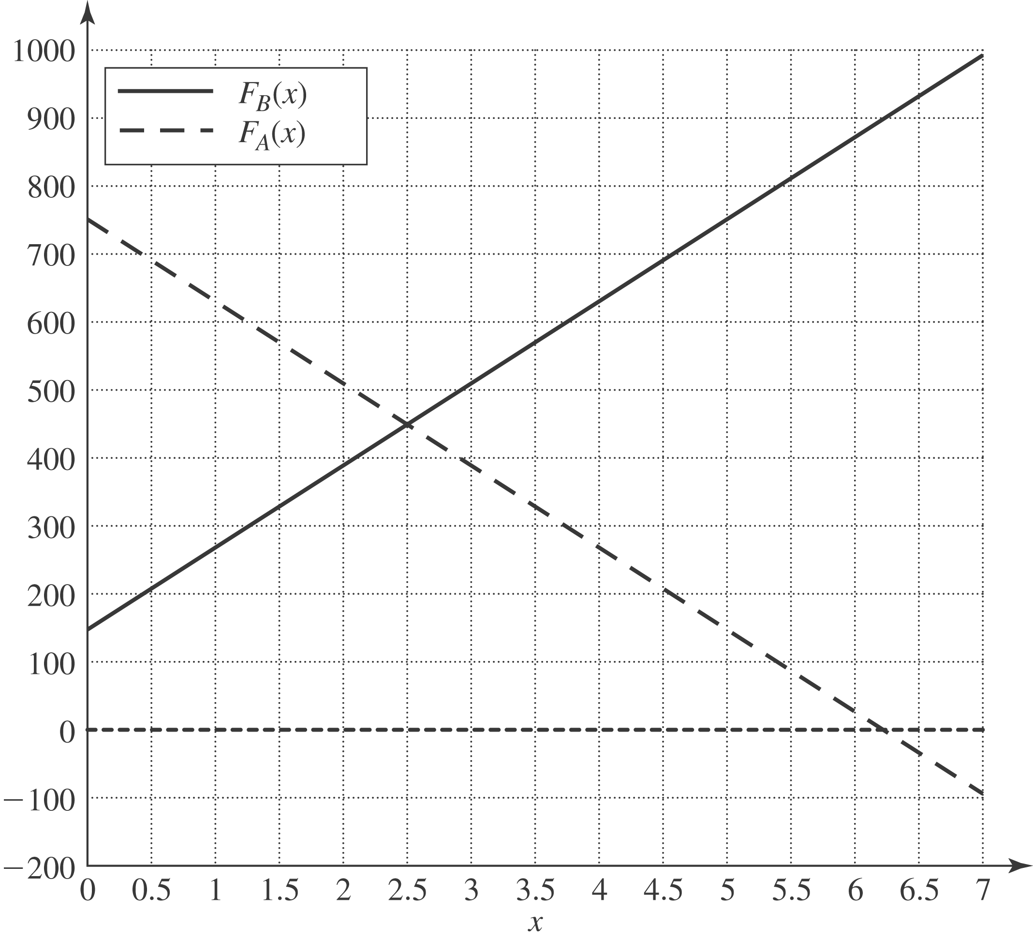

b) 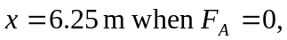which is 1.25 m beyond point B. c) Take torques about the right end. When the beam is just balanced, 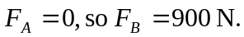The distance that point B must be from the right end is then 